**Project Design Phase-II**

**Technology Stack (Architecture & Stack)**

|  |  |
| --- | --- |
| Date | 15 October 2022 |
| Team ID | PNT2022TMID41272 |
| Project Name | Hazardous area monitoring for industrial plant |
| Maximum Marks | 4 Marks |

**Technical Architecture:**

The Deliverable shall include the architectural diagram as below and the information as per the table1 & table 2

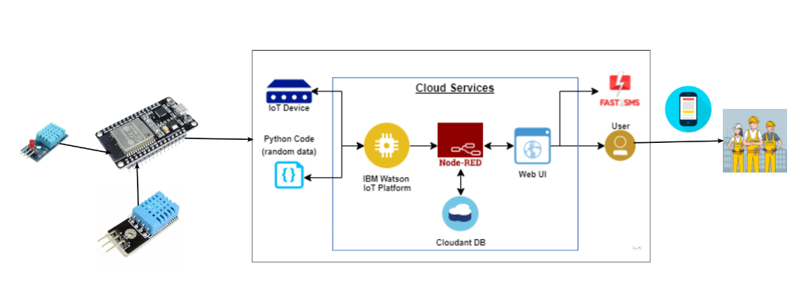

**Table-1 : Components & Technologies:**

|  |  |  |  |
| --- | --- | --- | --- |
| **S.No** | **Component** | **Description** | **Technology** |
|  | User Interface | User can interact through mobile app application | HTML, CSS, JavaScript / Angular Js / React Js etc. |
|  | Application Logic-1 | Used to measure the environmental parameters like temperature and humidity etc…. | Python. |
|  | Application Logic-2 | It is used to build a communication interfaces between two different application | IBM Watson Assistant |
|  | Database | MySQL is a relational database.Used to show the collected data in the tabular form. | MySQL. |
|  | Cloud Database | Cloudant is a non-relational, distributed data base service, which handles software and hardware provisioning, management and scaling, and support. | IBM DB2, IBM Cloudant etc. |
|  | File Storage | Using IBM block storage the collected data’s are stored permanently. | IBM Block Storage or Other Storage Service or Local Filesystem |
|  | External API-1 | The purpose of this API is to collect the required data from the cloud. | IBM Weather API, etc. |
|  | Machine Learning Model | Beacon devices are integrated in the working place and also in wearable devices .It is used to sense the temperature and humidity of that particular place and it is display in digital form in the wearable device | Object Recognition Model, etc. |
|  | Infrastructure (Server / Cloud) | Application Deployment on Local System : | Local, Cloud Foundry, Kubernetes, etc. |

**Table-2: Application Characteristics:**

| **S.No** | **Characteristics** | **Description** | **Technology** |
| --- | --- | --- | --- |
|  | Open-Source Frameworks | KAA IoT, ZETTA,GE PREDIX, Thing speak | KAA IoT |
|  | Security Implementations | Mandatory access control, Discretionary access control, Role-based access control, Rule-based access control. | e.g. SHA-256, Encryptions, IAM Controls, OWASP etc. |
|  | Scalable Architecture | It refers to a system, network or process that is designed to handle a workload that may change in scope. | Kubernetes, elastic storage, load balancers. |
|  | Availability | Equipment availability is a metric used to measure the percentage of time a machine can be used. | Technology used |
|  | Performance | Need to simulate devices from different locations with required network technologies. | Machine learning algorithms |